FMX Mobile Application Development

LAB EXERCISE 03.01: Home and Login Screens

To help get us started with our FMX cross-platform UIs, we will use two of the included FMX GUI Templates; The Home Screen and the Login Screen.
The FMX GUI Templates are a set of UI template projects for FireMonkey in Embarcadero RAD Studio available via Embarcadero GetIt.
You can access these Templates using Tools | Getit Package Manager, select Sample Projects Category.
For the sample Mobile application, we will install the Delphi Home Screen and the Login Screen applications.
Steps:
1. On the 10.3 Rio IDE Welcome Page, click Get Add-Ons from Getit
2. Select Sample Projects Category | Select App Home Screens | Install | Close
This installs a sample Welcome / Home Screen application in your default folder: C:\Users\Public\Documents\Embarcadero\Studio\20.0\Samples\Object Pascal\App Home Screens\
3. You have 3 projects with Home Screens.
4. Open HomeProject2. HomeProject2 looks like this:
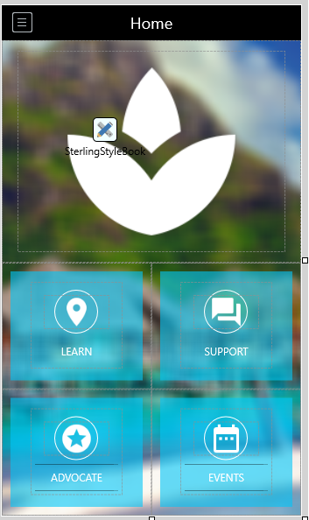
5. Let's use this HomeProject2 as our Main Form, Home Screen for our FMXMobileApplication.
6. File | Save Project As | New Folder | C:\Users\amannarino\Documents\Embarcadero\Studio\Projects\ FMXMobileApp Project Name = FMXMobileApp

Next, let's use one of the 10.3 Rio templates for our Login Screen.
Login Screens
1. Using GetIt Project Manager, Sample Projects, Select and Install the Login Screens.
2. The Login Screen app gets installed in this default location, C:\Users\Public\Documents\Embarcadero\Studio\20.0\Samples\Object Pascal\Login Screens\
You have 3 projects with different Login Screens. LoginProject2 look like this:
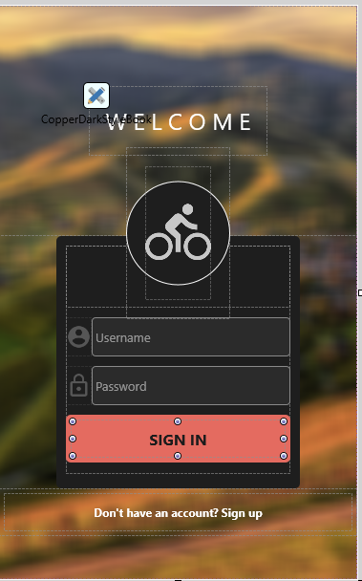
3. File | Save All, File | Close All.
We will use these two units; uHomeFrame2.pas and uLoginFrame2.pas as the starting screens for our FMX Mobile Application.

